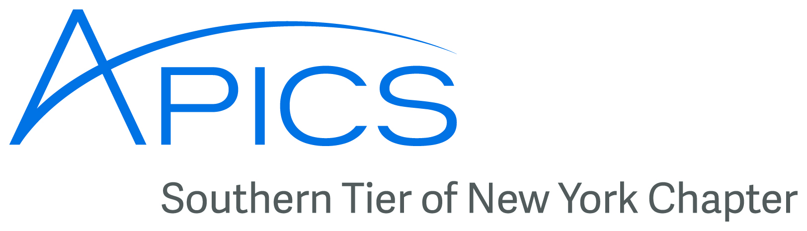
April 2016
www.stapics.org

Message from our President
It’s Board of Directors Election Time, folks!

Yes, it’s that time again! Time for us to beg, plead, cajole, wheedle, entrap, beguile, beseech, implore [thank you, Roget] you to consider serving on the Board of Directors of your local APICS chapter.

“Why would I want to do THAT?” you might ask.

“Well,” we would respond, “because it allows you help ensure the future of the chapter. Because it will let you correct the sins of commission and omission that you complain about. Because it allows you to ‘give back.’ Because it’s not good when the same people serve year after year. Because it’s worth a few annual points for your certification continuing education credit requirements. Because you get a free dinner once a month when we meet to discuss chapter issues.”

I could go on, but I think I’ve given you ample reasons!

So if I have sweet-talked you into wanting a position on the Board, please send one of us an email, and try to attend our next meeting on Wed. May 11, 2016. We’d love to hear from you and love to have you on the Board!

Side note: you do have to be a member of the chapter. If you’re not a member yet, and you want to serve on the board, becoming a member is very easy, so don’t let that scare you away.
Upcoming Events
Ametek Aerospace & Defense Tour – AMETEK Aerospace & Defense is a leading manufacturer of highly engineered and cost effective engine sensor suites, aircraft data management systems, cooling and ventilating systems, environmental control systems, and a variety of sub-assemblies to military and aerospace customers.
When: Friday, April 29th at 3 PM
Where: 33 Lewis Rd # 6, Binghamton, NY 13905
Student Chapter Updates
The Binghamton University Student Chapter will hold their Eboard elections in May. The new Eboard members will take office when classes reconvene in the Fall.

Current Eboard:
President - Sabrina Candido
Vice President - Seonjung Park
Secretary - Greg Linden
Treasurer - Eric Hirsh
Student Liasion - Westin Zeng
Education Updates
The Basics of Supply Chain Management (BSCM) course at SUNY Broome has been cancelled due to lack of interest.
The CSCP class will hopefully start in May, also at the SUNY Broome campus. Currently no one has signed up yet. Registration can be accomplished by calling SUNY Broome at 607-778-5012.
Don Sheldon is working with the winning team from the APICS Northeast District Student Case Competition to prepare them for the national championship in September. He has the TTT instructor kit (borrowed from district) to use with the winning team prior to September competition.


Have News, Events, or Items of Interest?
To have it included in next month’s newsletter
email it to jedestrada.writer@gmail.com by next
month’s B.O.D. meeting on May 11th.
___________________________________________________________________
Board of Directors 2016
President  Dave Gardner, CPIM  dgardner@emtmetals.com  Executive VP /Director of Finance  Steve Whited  steven.whited@acco.com  Secretary  Debbie Unkel, CPIM  deb.unkel@raymondcorp.com  Director of Programming  Steve Stanchak, CPIM  sstanchak@stny.rr.com | Director of Membership/Director of Chapter Standards/Director of Online Publication  Lee Schechter , CPIM  lschechter@stny.rr.com  Director of Education/2nd Director of  Student Relations  Don Sheldon, CFPIM CIRM CSCP  dsheldon@sheldoninc.com  Director of Communications  Jed Estrada  jedestrada.writer@gmail.com  Student Chapter Liaison  Westin Zeng  szeng2@binghamton.edu
Southern Tier APICS
PO Box 1107
Binghamton NY 13902-1107

